Github Actions
https://github.com/mbel12345/final

Github actions completed
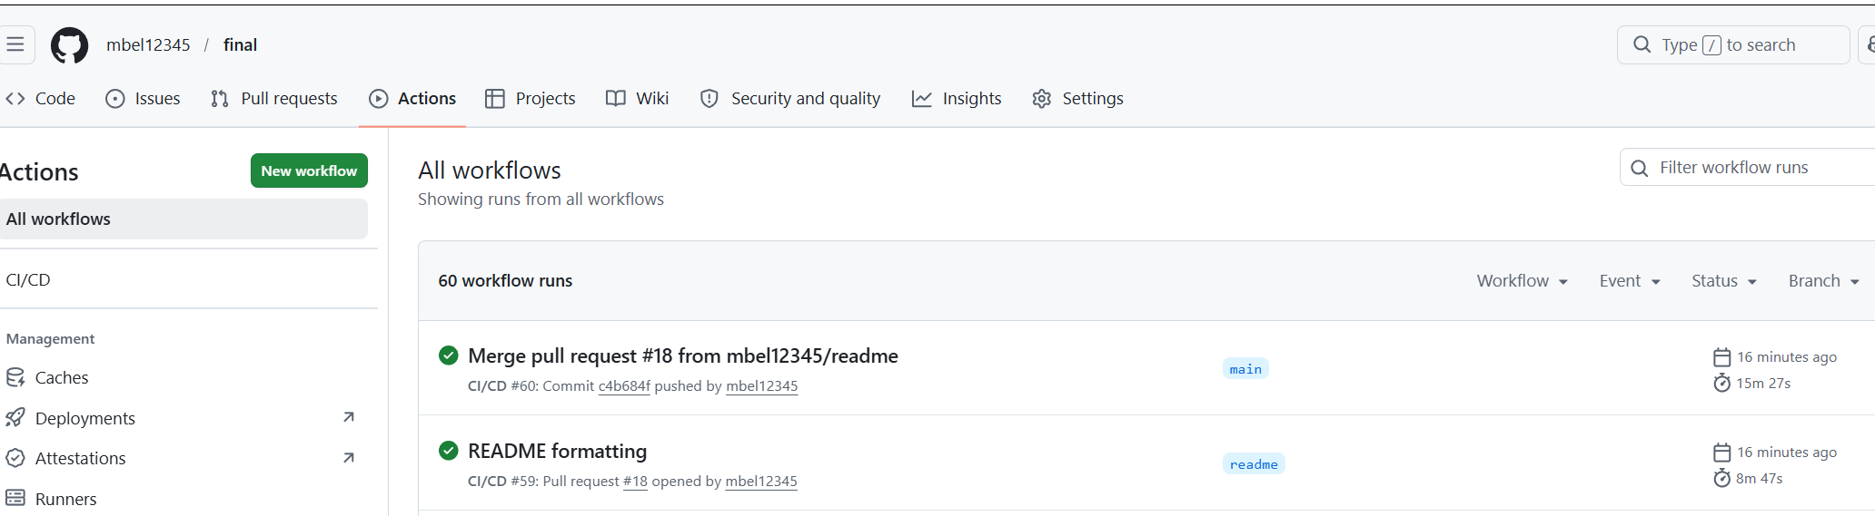

The Merge Action for example
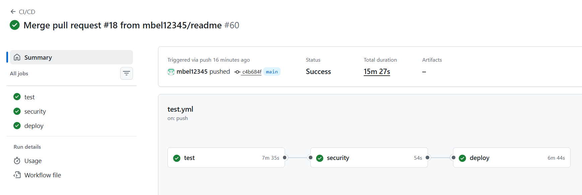

Example step for the Action (Test)
Includes playwright tests (test_ui.py) and routes (test_routes.py)
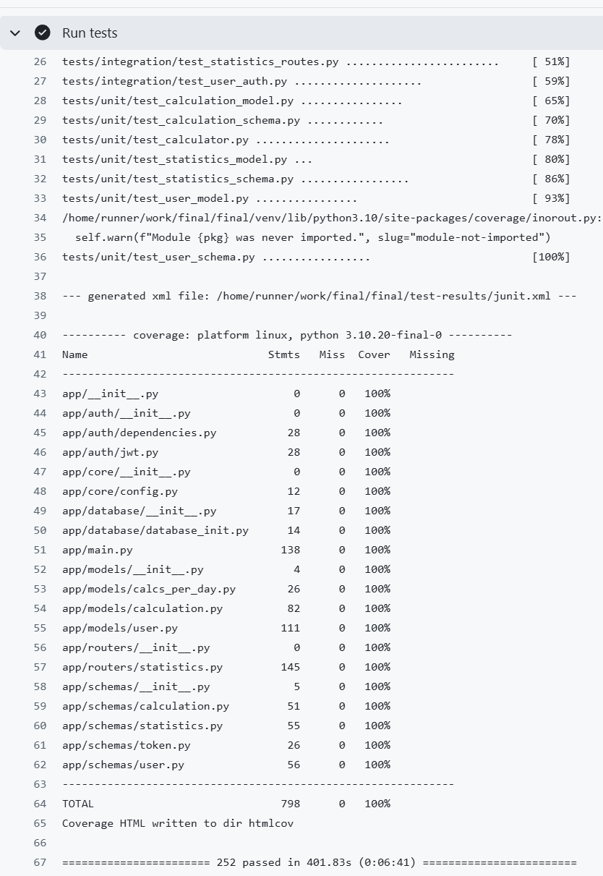

DockerHub Link
https://hub.docker.com/r/msb64/final
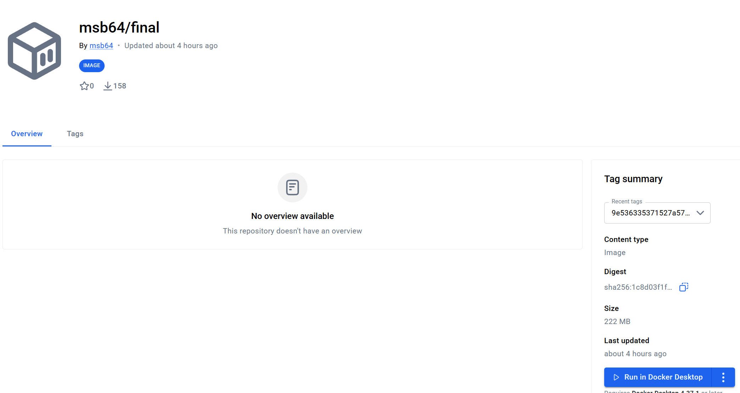

Front-End Screenshots (New Features)

Navigation / Dashboard
I added a Navigation page to the top and entered some calculations manually so I can verify the Statistics Page
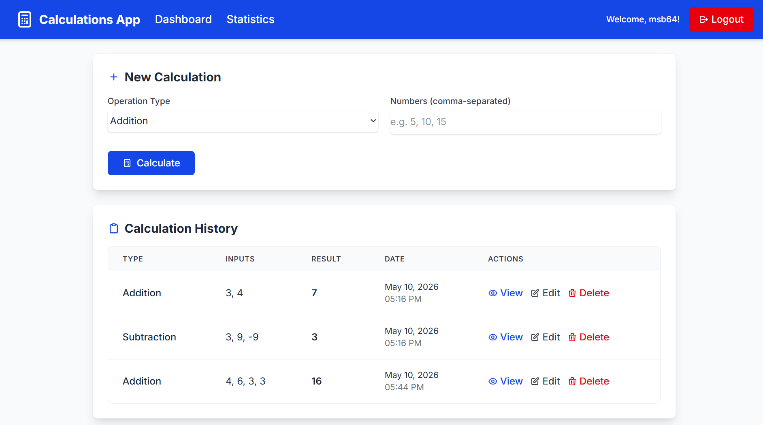

Total Calculations

No Filters
Refresher:
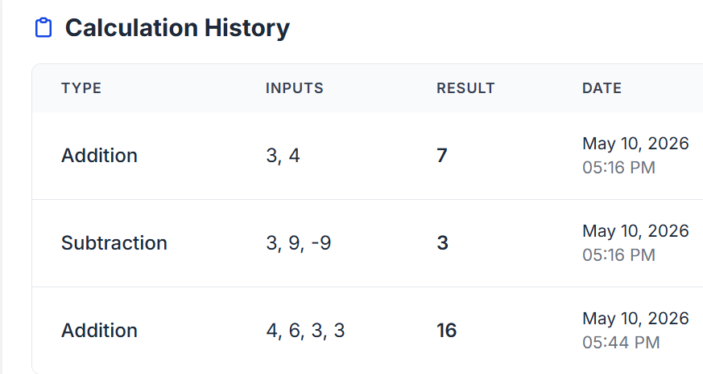
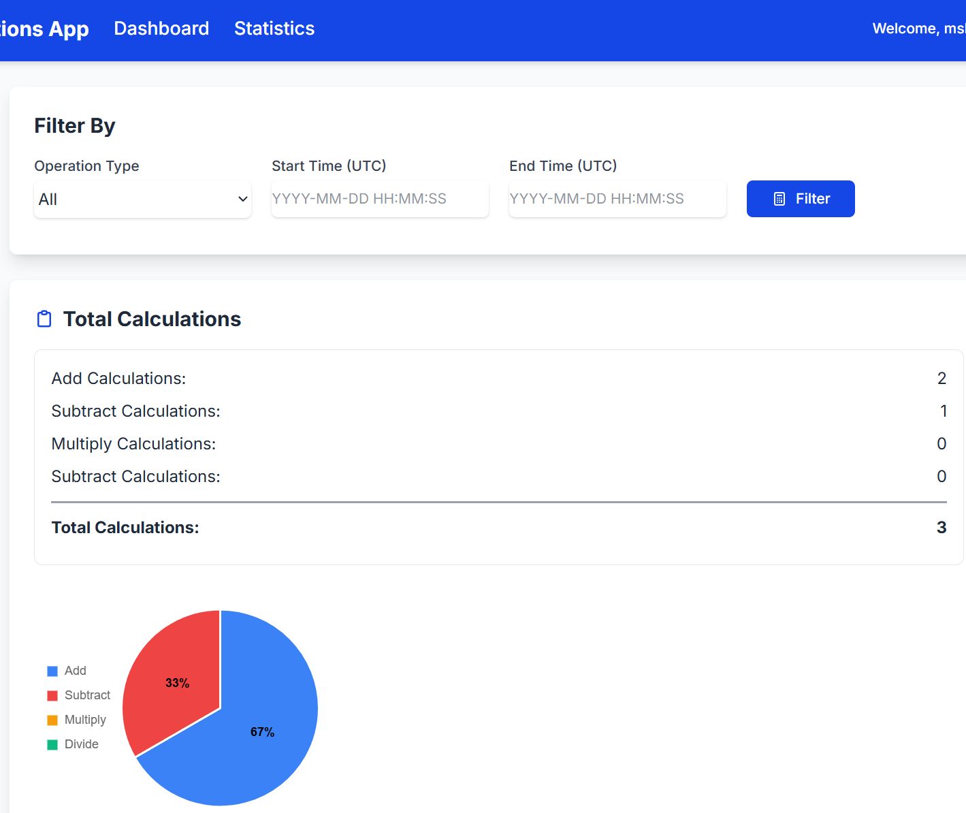

Filter by Start Time
Refresher:


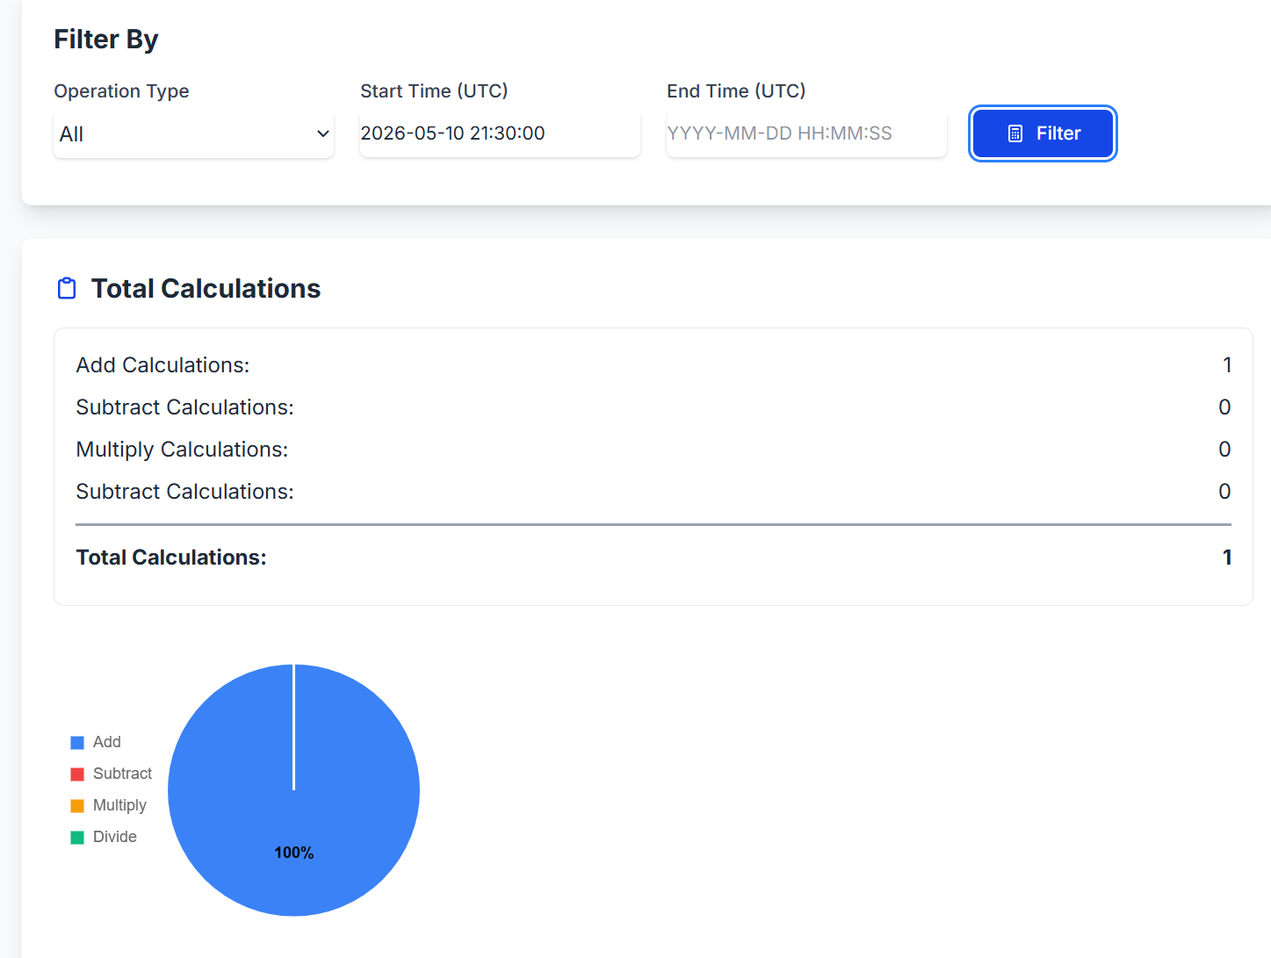

Filter by End Time
Refresher:


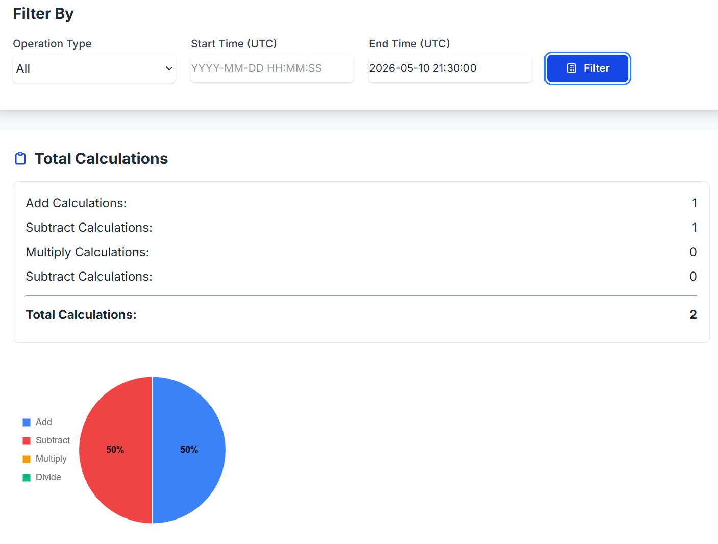

Average Operands and Average Result

No Filters
Refresher:


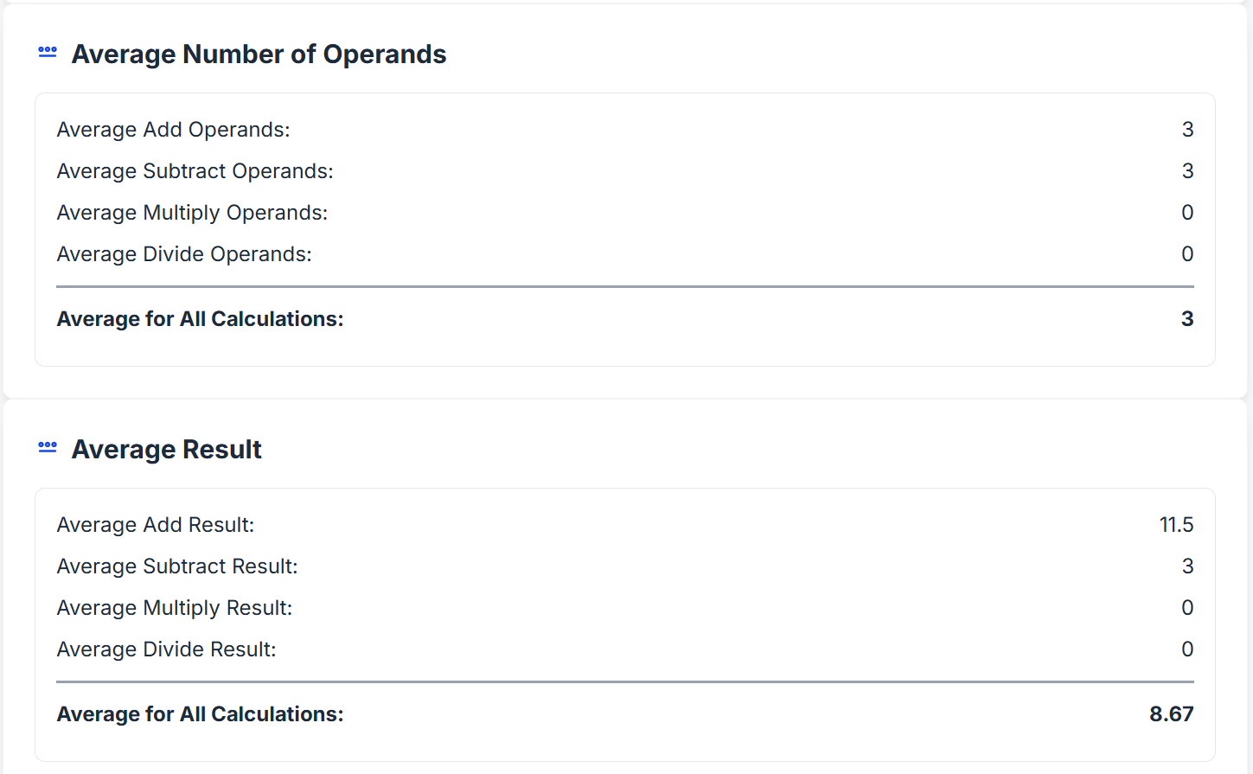

Filter by Start Time
Refresher:

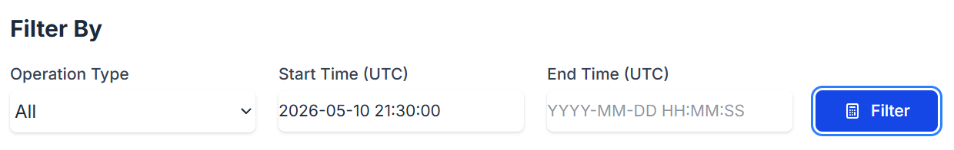
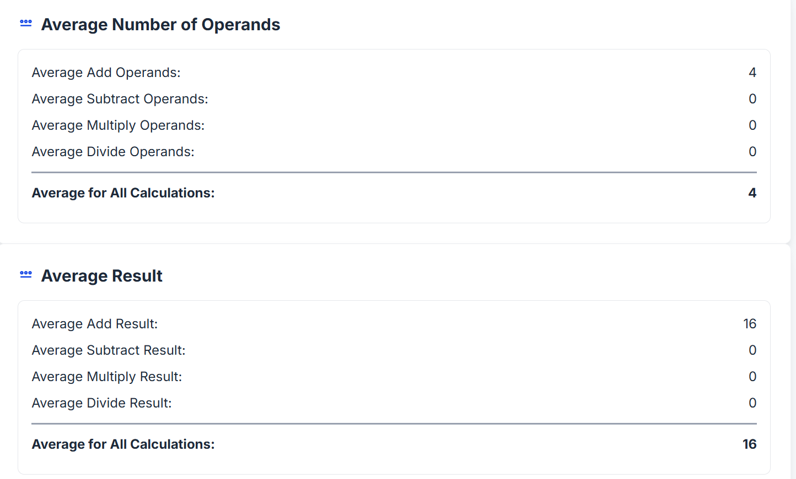

Filter by End Time
Refresher:

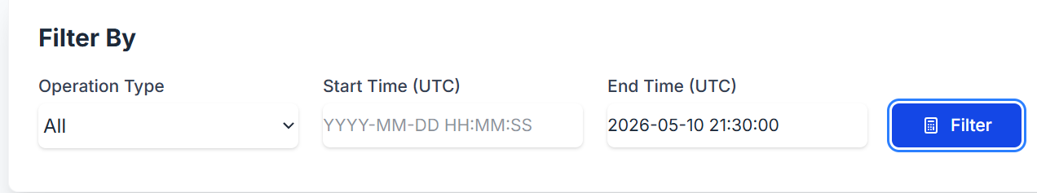
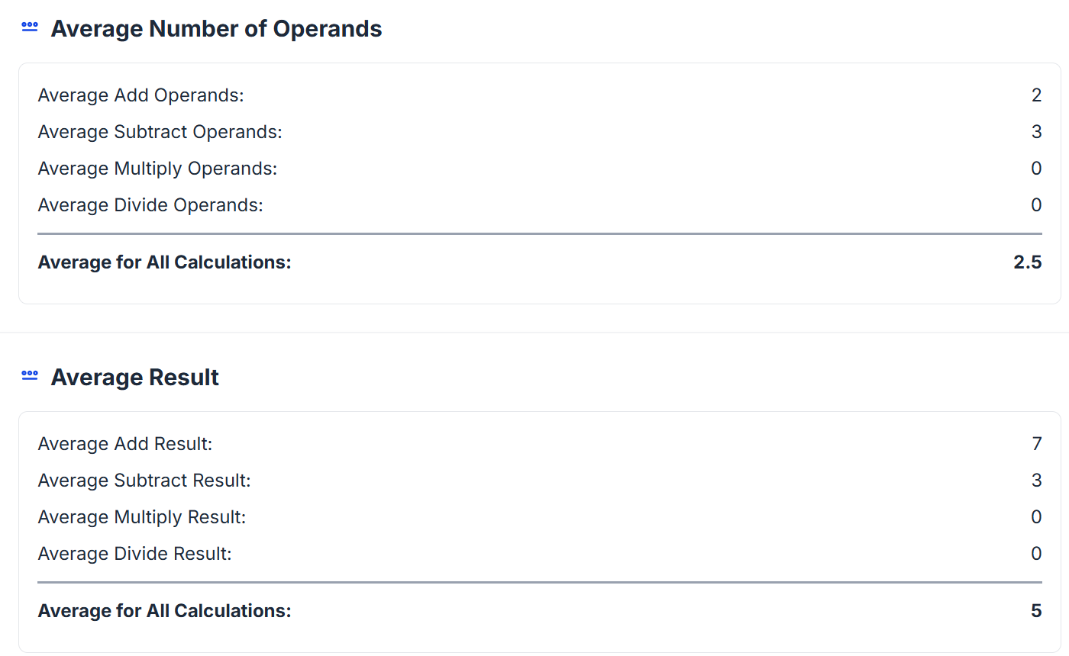

Calculations Per Day
Refresher:


No Filters
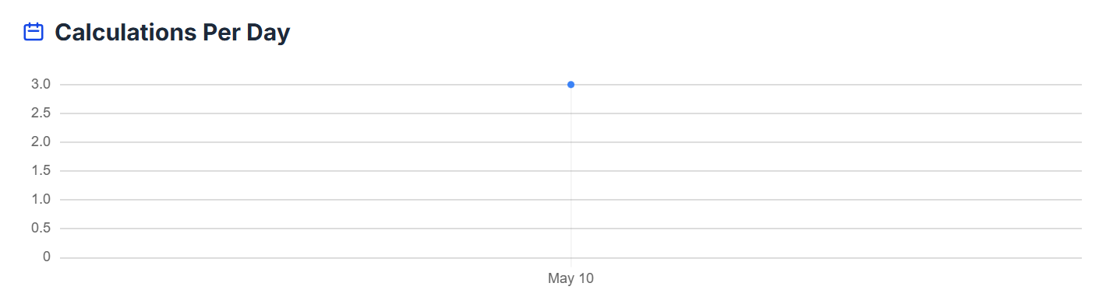

Filter by Start Time and End Time
The above does not fully demonstrate the line graph, so I wrote a data import script to verify it. Run the job to import dummy data, then login as the user shown in the output. Because it is dummy data inserted into calcs_per_day table, the Total Calculations section is empty
(venv) matt@matt:~/masters/masters_spring_2026/final$ python3 -m tests.e2e.add_test_data
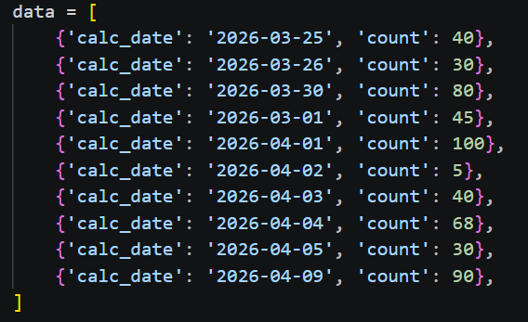
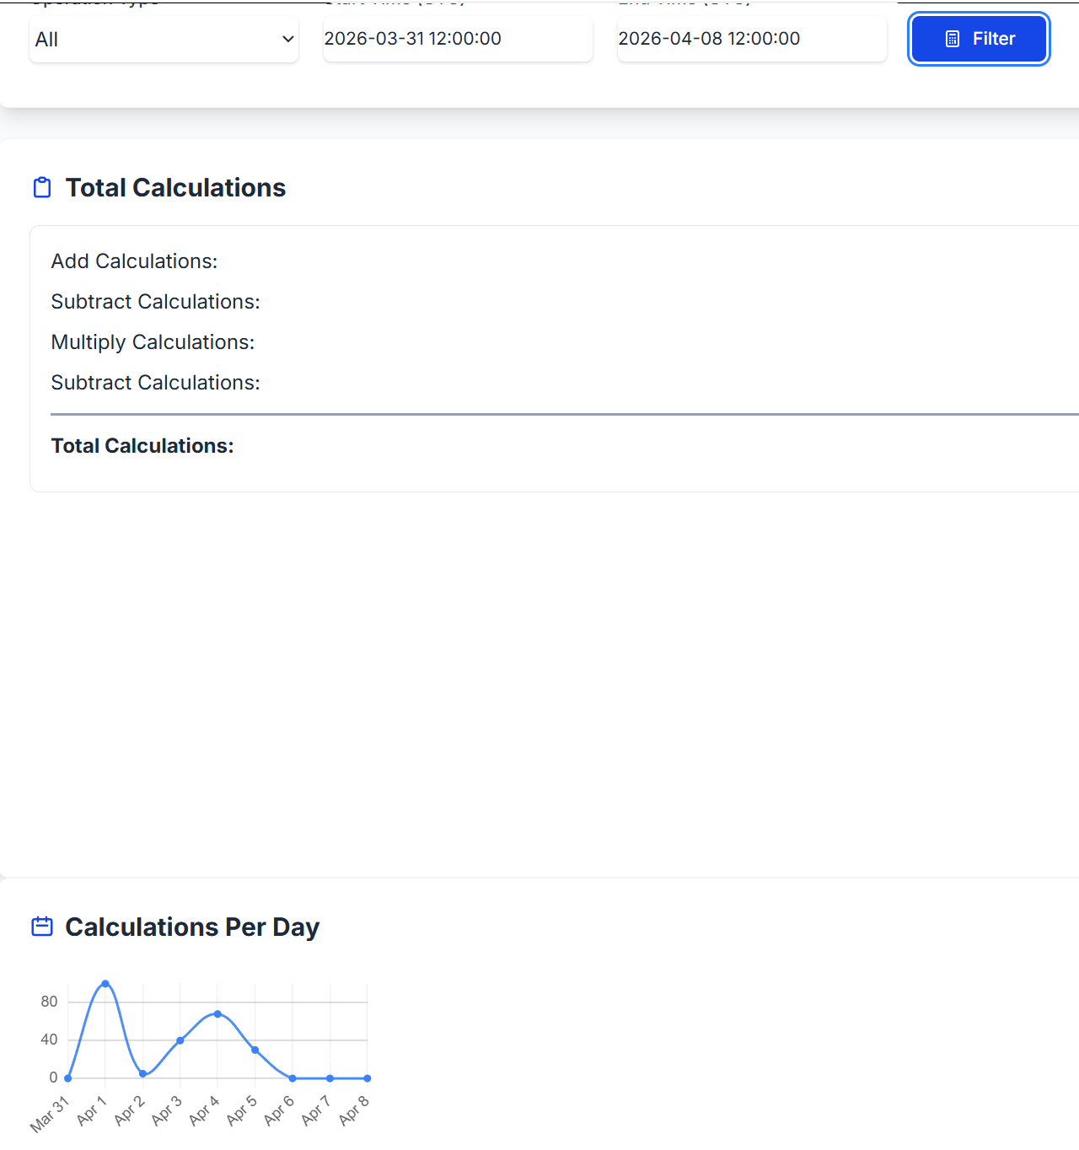

Front-End Screenshots (Existing Features)

Home
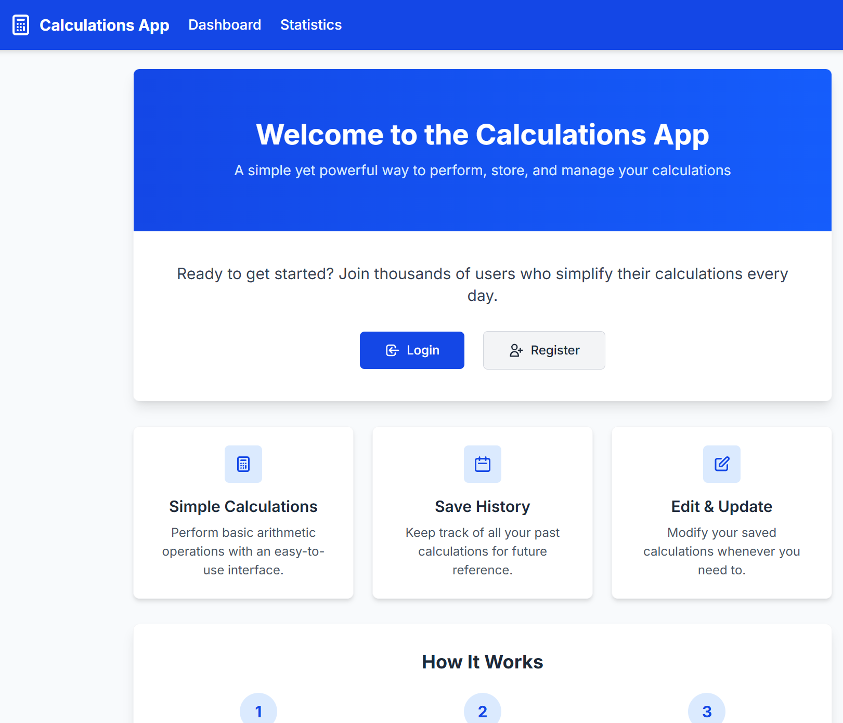

Register
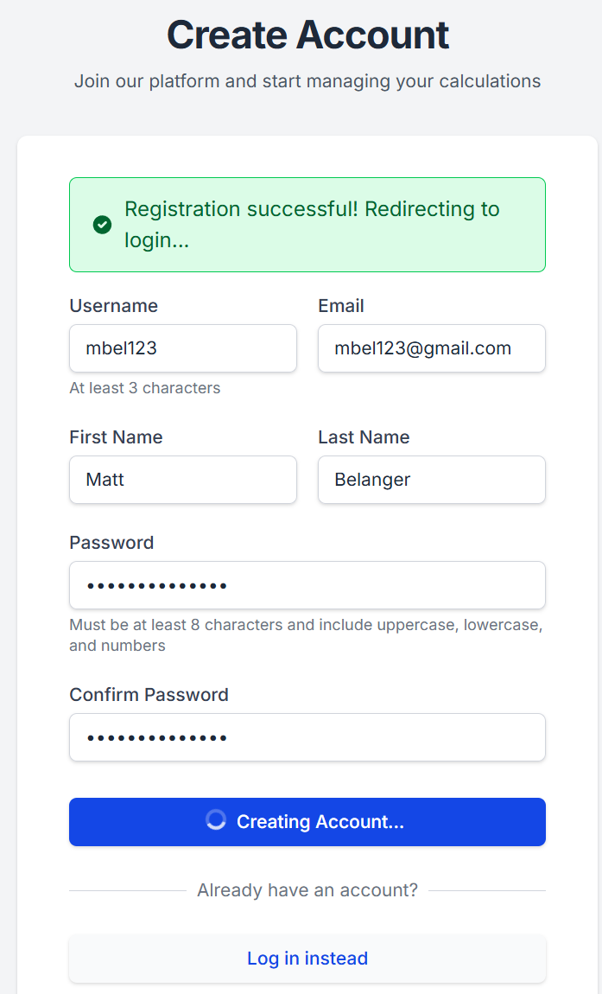

Login
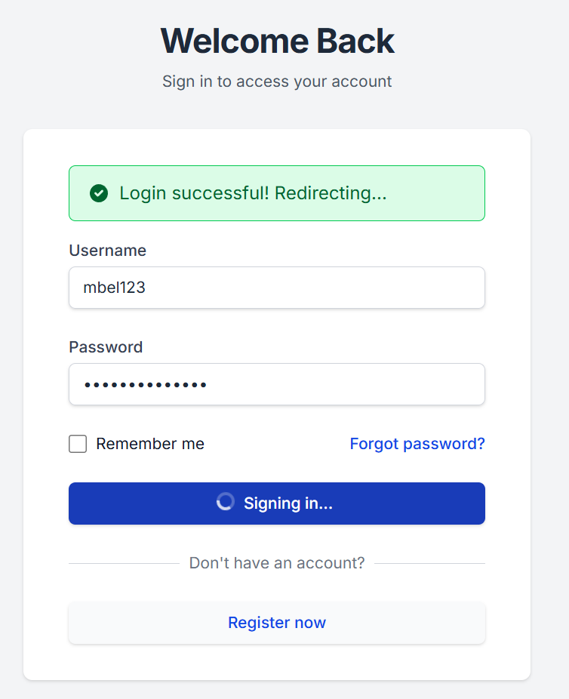

Empty Dashboard
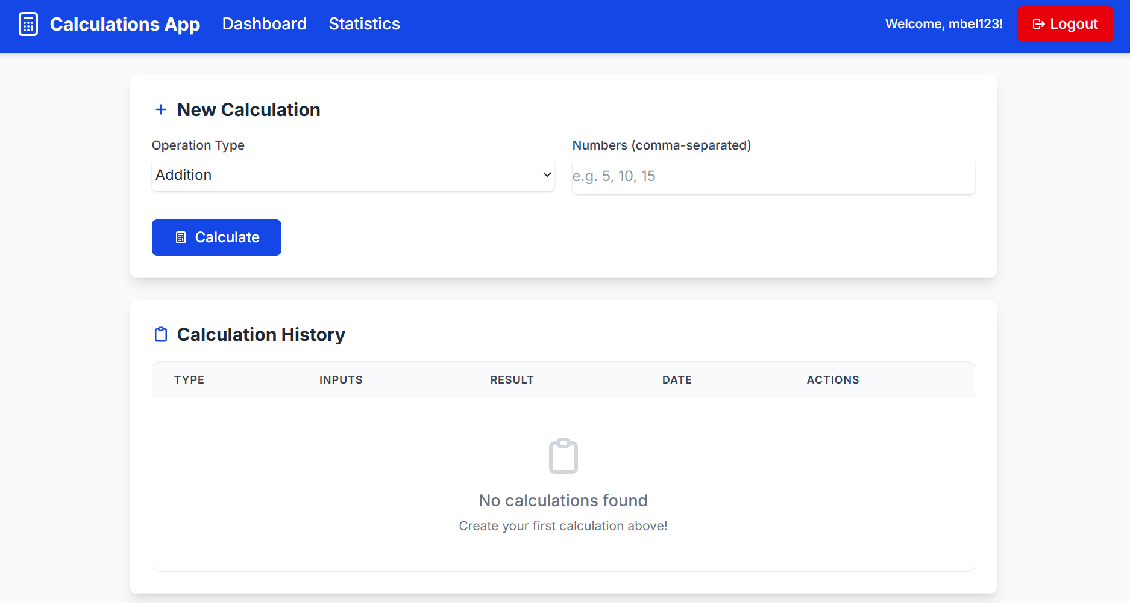

Add (Create) Calculations

Valid Data
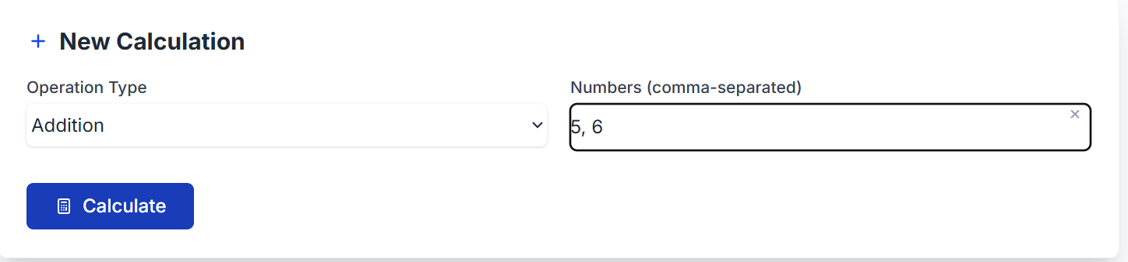
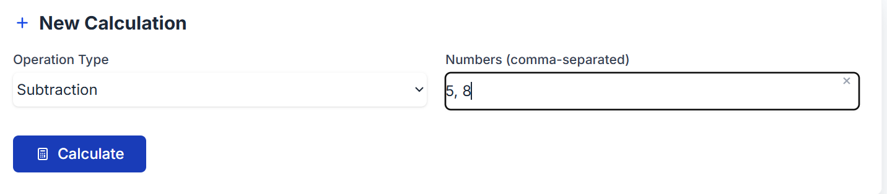
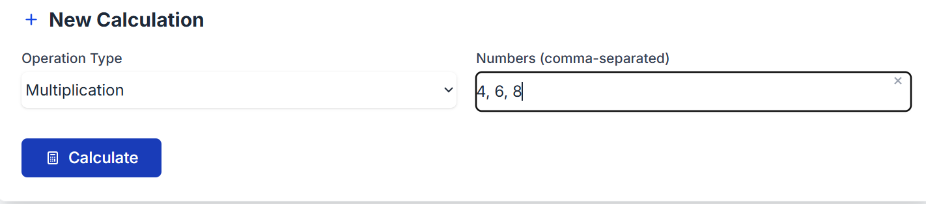
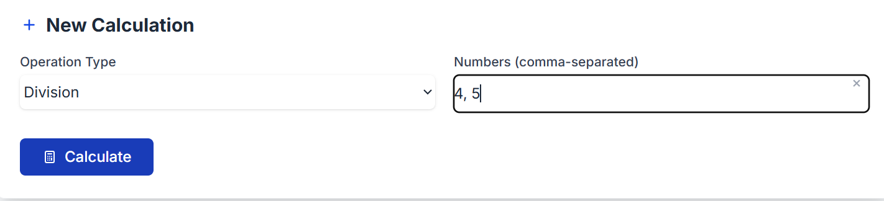

Invalid Data
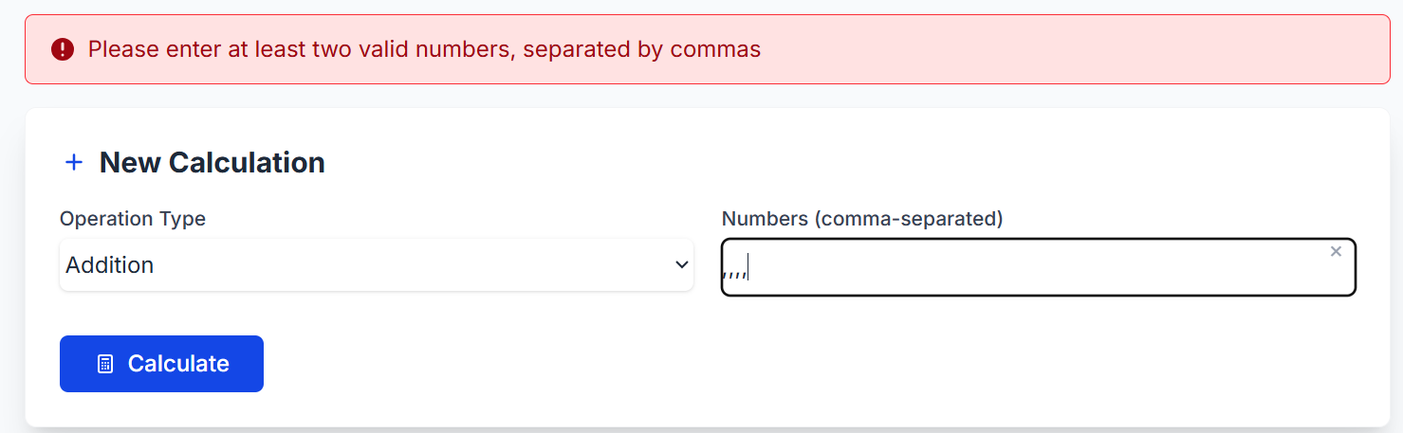
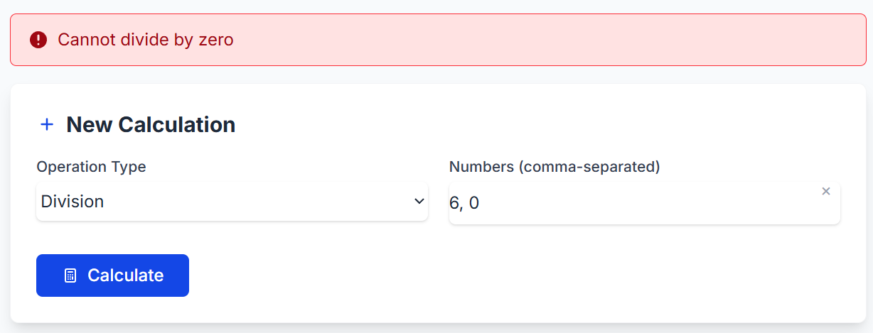

Browse Calculation
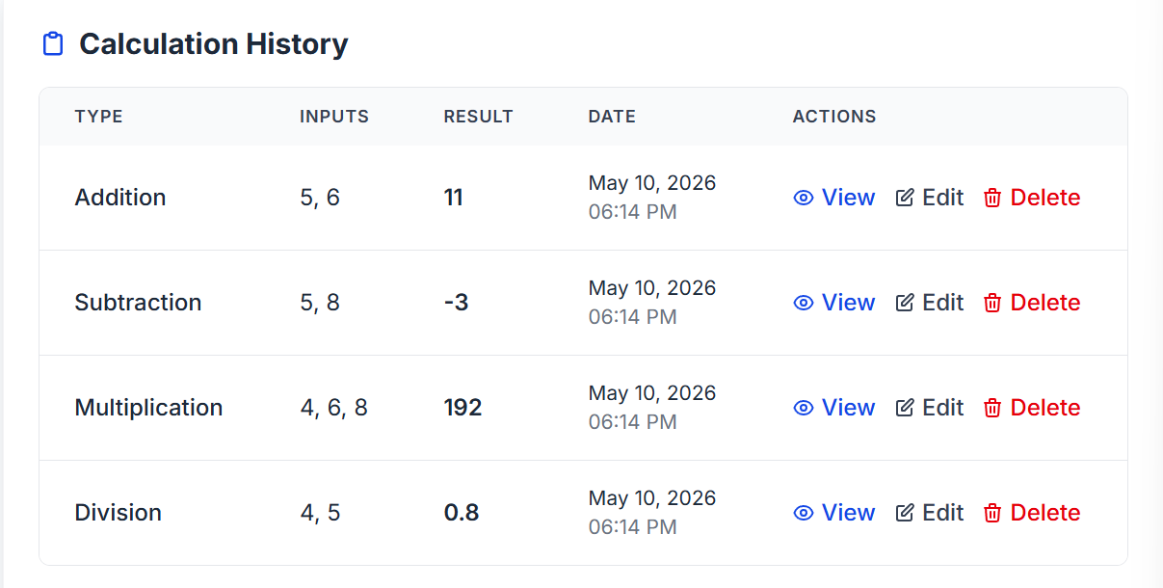

Delete First Calculation
Click Delete button for first row
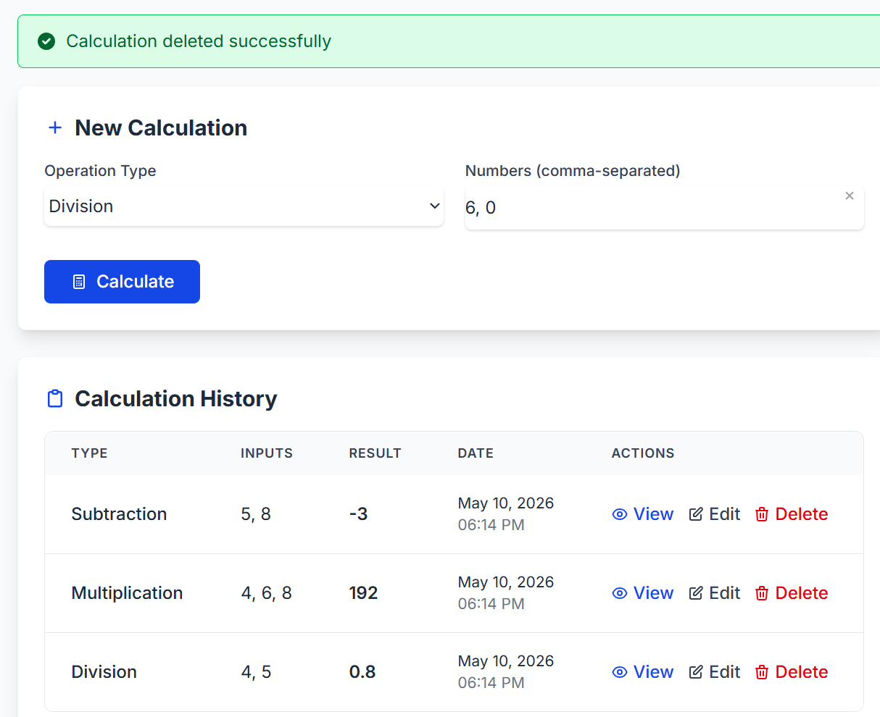

Read (View) Calculation
Click on the first row View
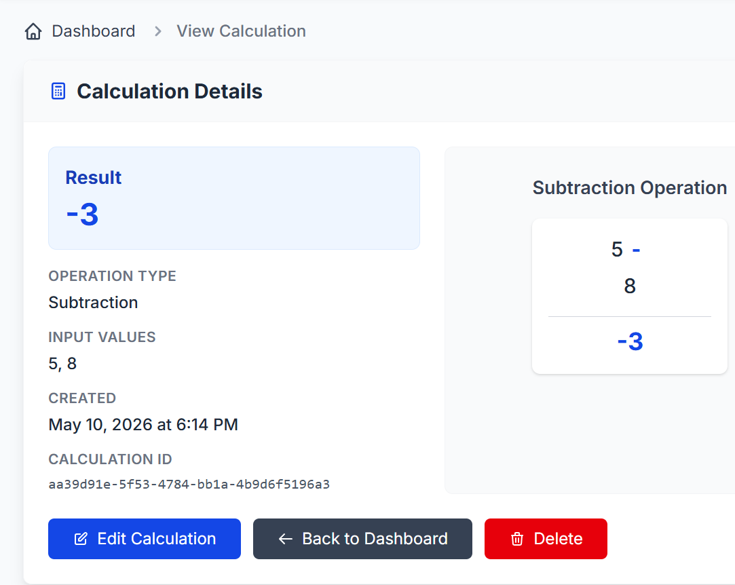

Edit Calculation

Before Changes
Click “Edit Calculation” on previous page, you get brought to:
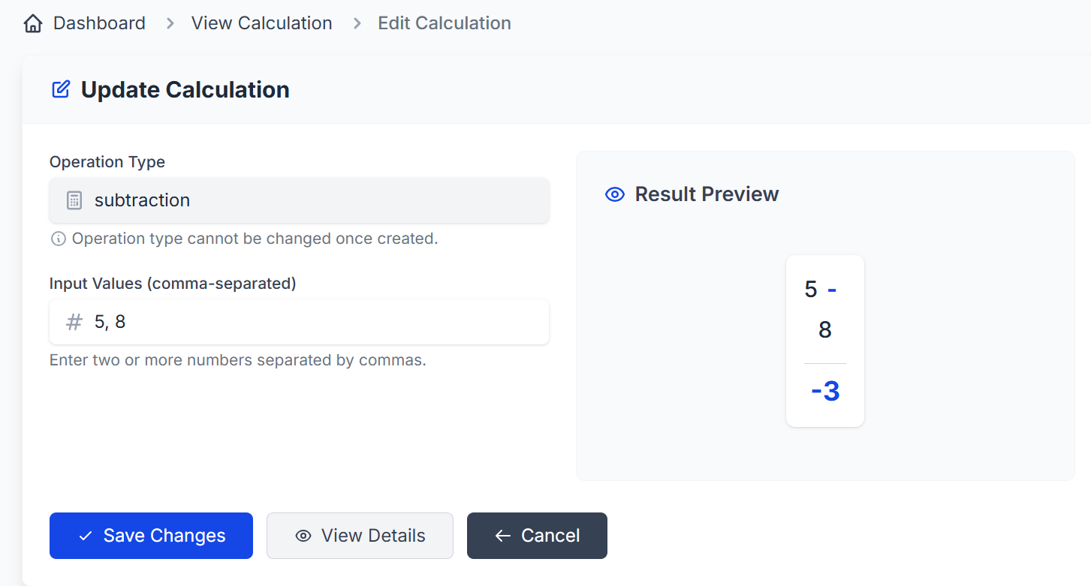

After Changes
Modify the Input Values, then “Save Change”
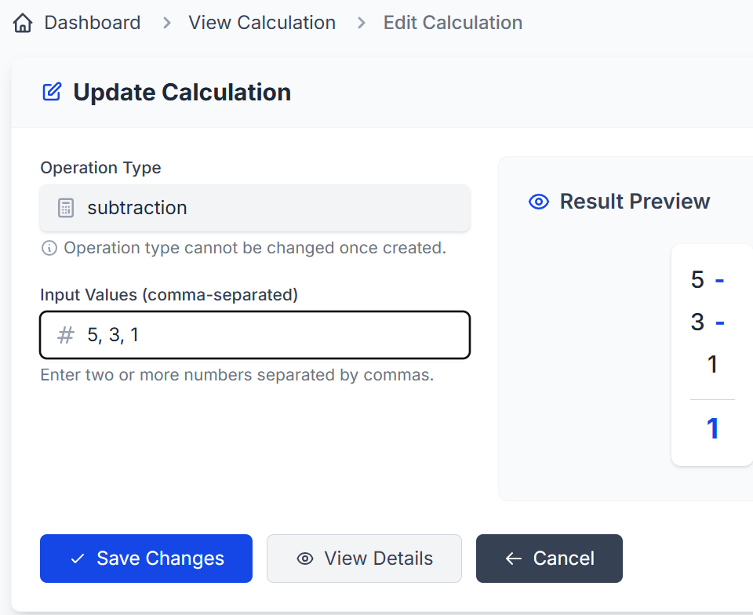

Change is reflected in the Dashboard
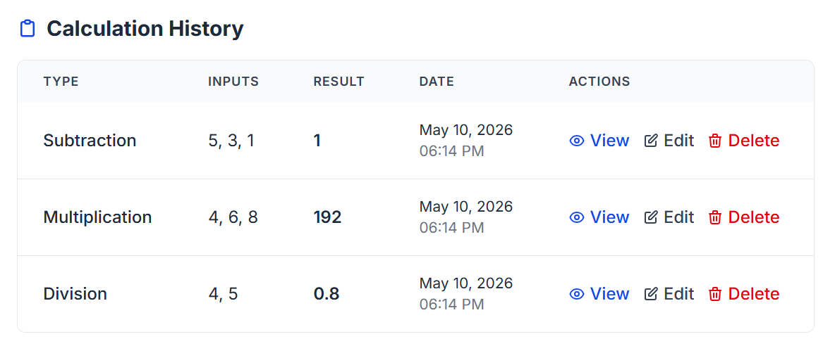

Attempt invalid modification
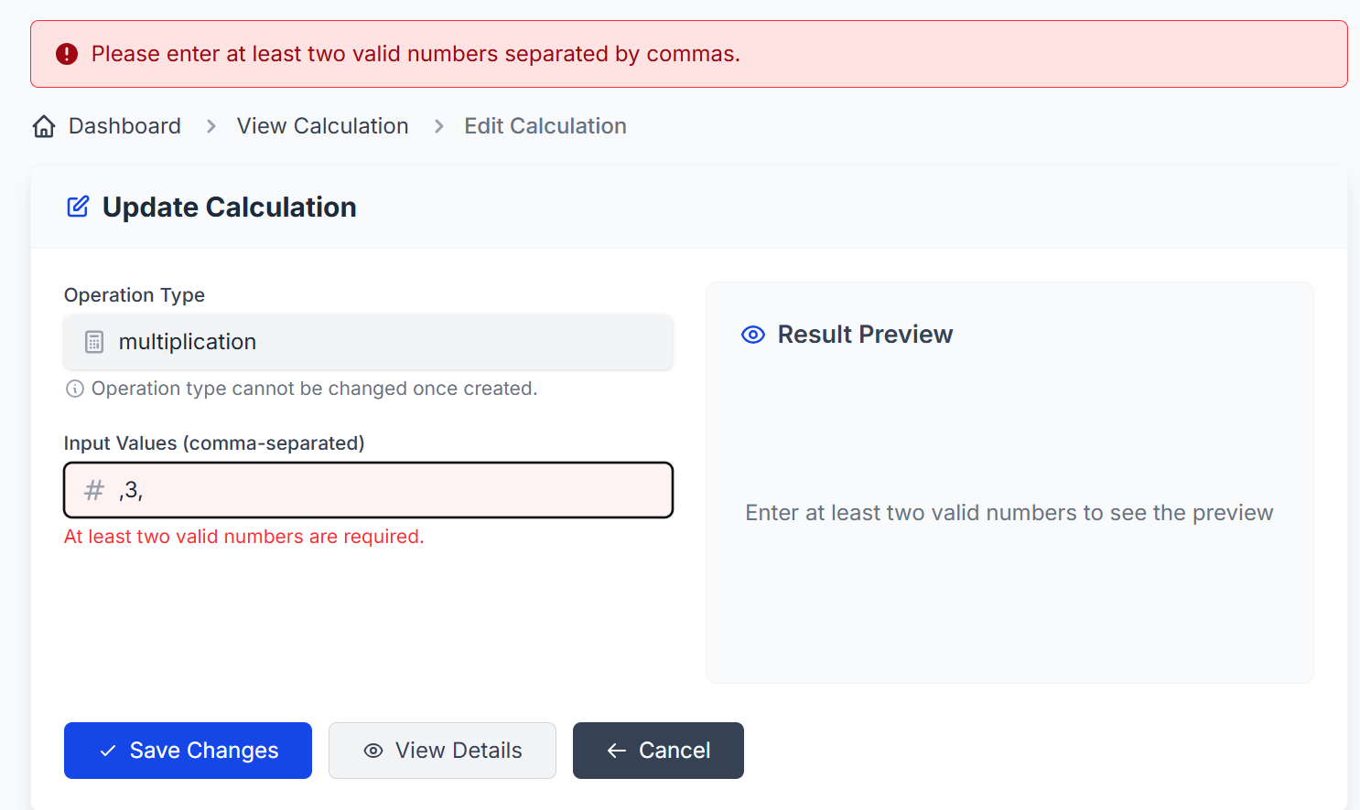

Attempt Division by Zero
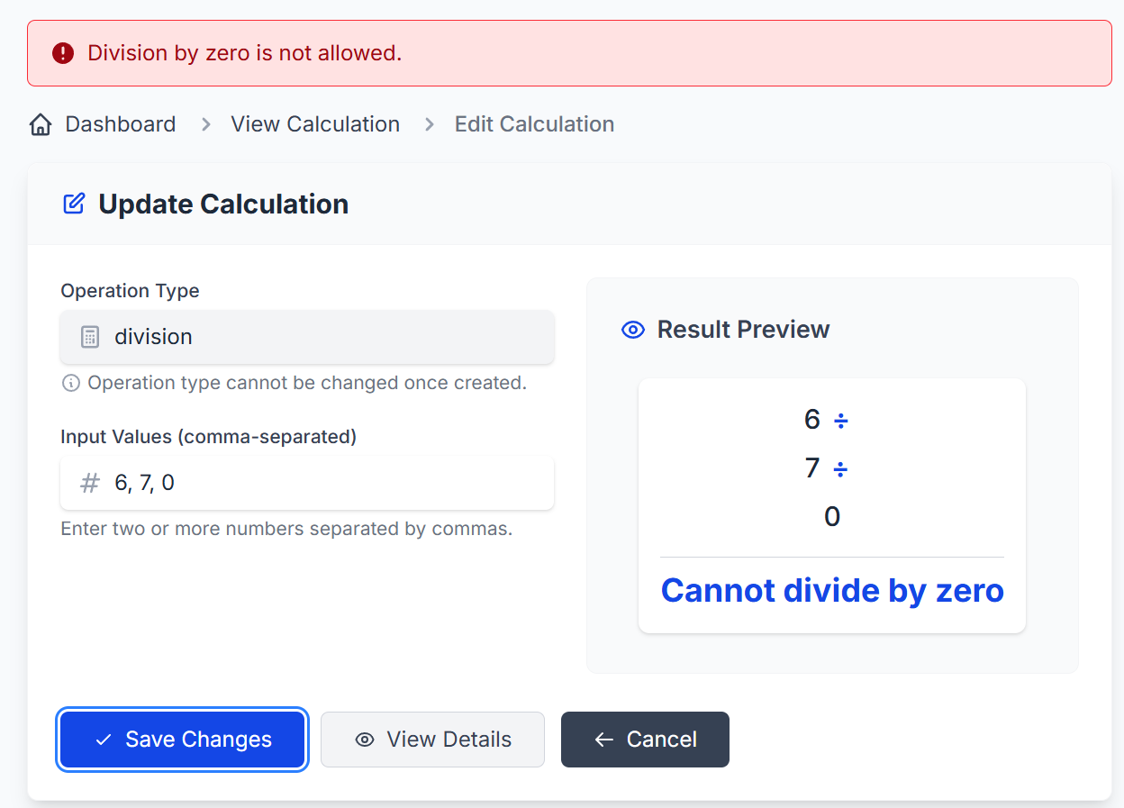

Logout
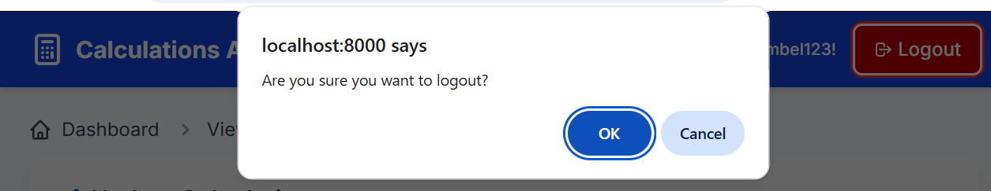
You get rerouted to login page
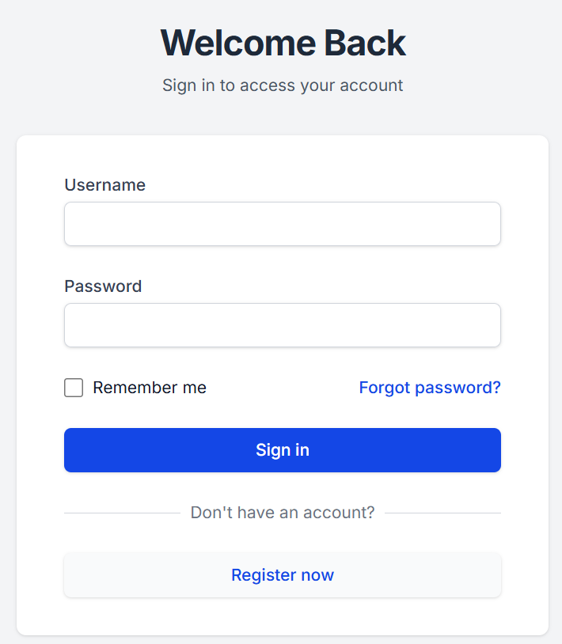

Run Test Cases Locally
(venv) matt@matt:~/masters/masters_spring_2026/final$ docker compose down -v && docker compose up --build
(venv) matt@matt:~/masters/masters_spring_2026/final$ pytest
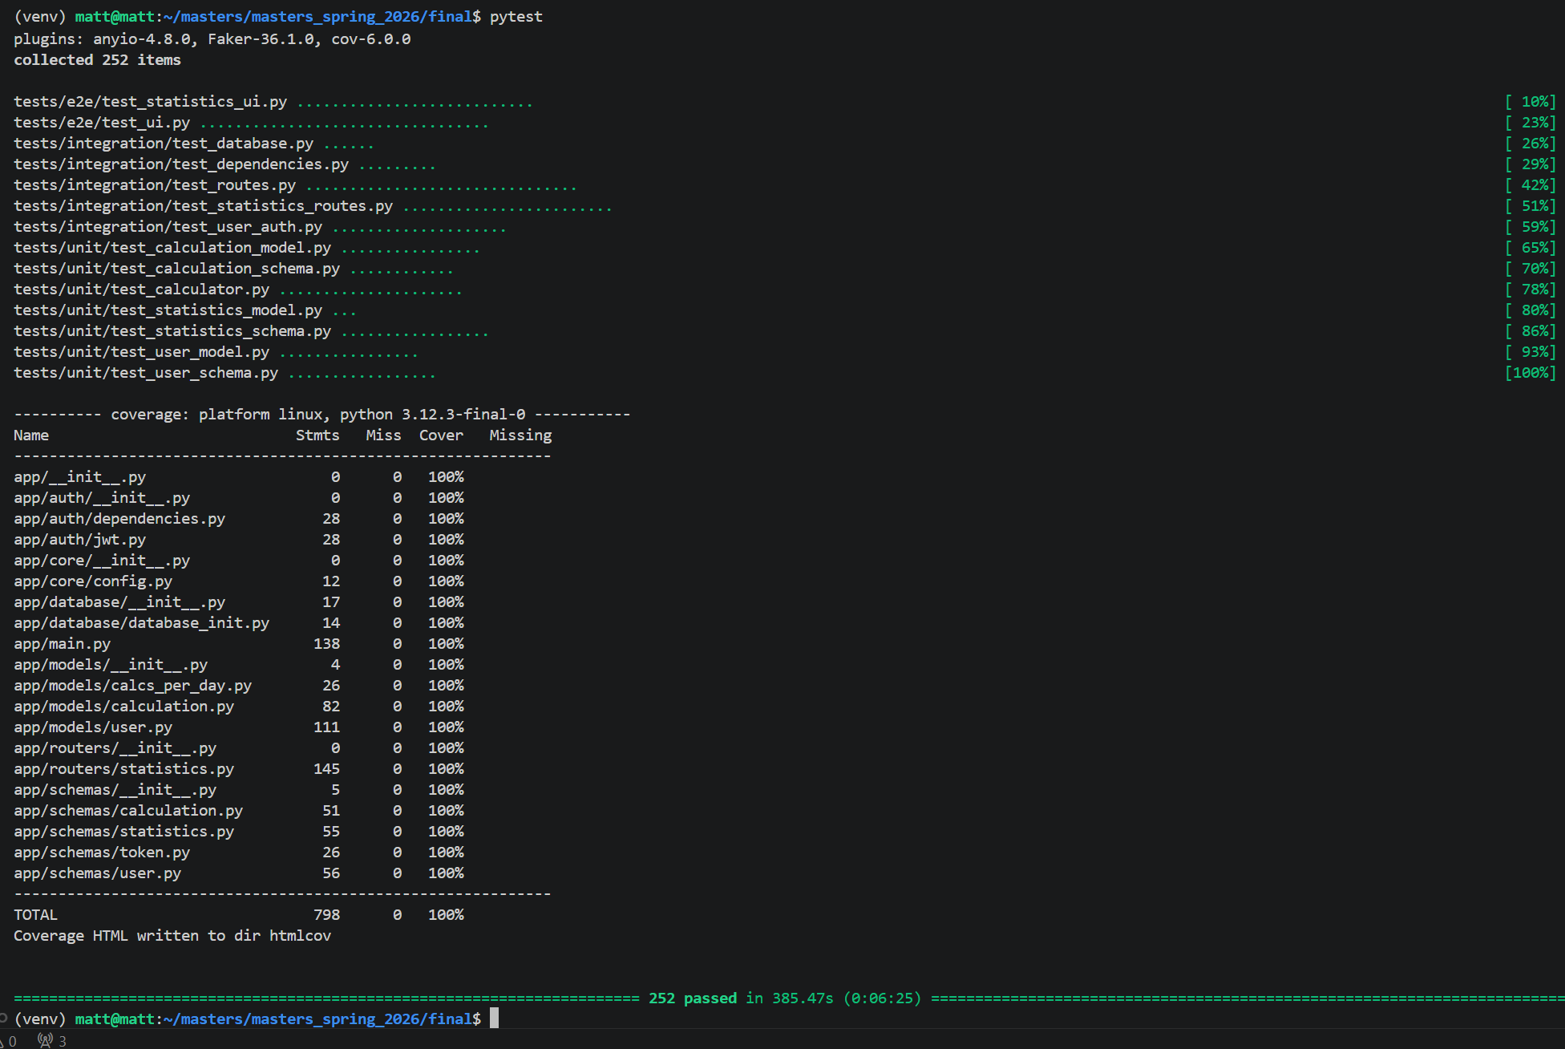

Reflection
Some of the playwright tests were challenging to write. For example, for my Charts, I kept trying to assert that the canvas was hidden when there was no data, but the behavior of the canvas teardown made this fail sporadically. My solution was to check the presence of a “No data to display” type of message inside a nearby div instead. It was also tough to fully test my start_time and end_time filters, as they were based on calculation creation time, which was always on the current day. My workaround was to add steps to the beginning of my filter pytest cases to set the created_at to some previous day. This was also an issue for manually testing my line chart, so I wrote a standalone python script to upload data to the calcs_per_day table for previous days. I was also getting duplicate user/email messages in the test cases, so I standardized the way user data was defined in each test case: it is now always via create_unique_user_data method.
Another challenge was ensuring the graphs conformed to the look-and-feel of the overall page and were sized properly. This required lots of back-and-forth with copilot about potential settings to tweak, until I got a good look. Getting the formatting right on my statistics text charts was tricky, and so I had to experiment with various HTML classes until I got it right.
Overall, this project was a useful experience. It was helpful to be able to adapt the professor’s code to add my own page to the site, while learning from his best practices. It also gave me practice at integrating new features into an existing code base. The entire course structure was very helpful for learning how an end-to-end Python app works.

